Intro to Data Communications   
Dynamic Host Configuration Protocol (DHCP)

Last Updated: 2/21/2023 2:11 PM Version 2  
Document Prepared for: Professor Lindstrom's Student

# Name Peter Sanford ID 10934984

# Instructions

Answer all questions directly in this document. You will save and upload this completed document as your homework submission.

# Overview

In this lab you will learn how the Dynamic Host Configuration Protocol is used to provide convenient automatic IP Configuration. You will configure your firewall’s DHCP service and examine DHCP network traffic.

# Setup

Before we begin this lab you will need to configure a Windows Server. I have created a Windows server 2012 Virtual machine for class, use the following instructions to get your Server VM ready.

## Steps

1. Start your pfsense VM (ensure the first network adapter uses **NAT** and the second network adapter uses **VMNet11**).
2. **Do NOT start your Debian VMs**
3. Get a copy of the Server VM. If you are doing this in class get a flash drive from your instructor. If you are doing this from home you can get the zip file from canvas->files->software the file is big (7 gig) and will take a long time to download. (You can choose either the Windows 2012 server-most used worldwide for Microsoft or Windows 2019 as they have not changed that much)
4. Copy the **WinServer** folder in the zip file to your VM location.
5. Start a new instance of VMWare player. Open the WinServer.vmx in the WinServer folder
6. Modify the VM Settings as follows
   1. Network: use **VMNet11**
7. Start the Server VM
   1. Select **Copied** the virtual machine
   2. If you get an error about a device not available, select **No**.
8. This server has been preinstalled then “sysprepped”, what that means is that most of the installation has already been completed, all you need to do is answer a few questions.
9. After a little while you will see the Settings Screen  
   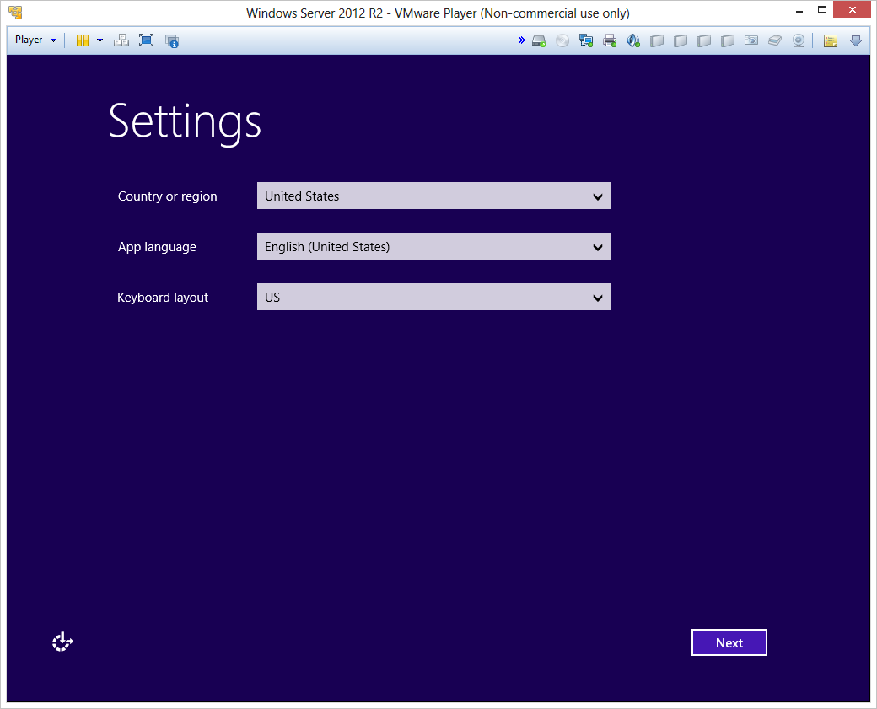  
   just click **next**
10. Next you will see the EULA screen  
    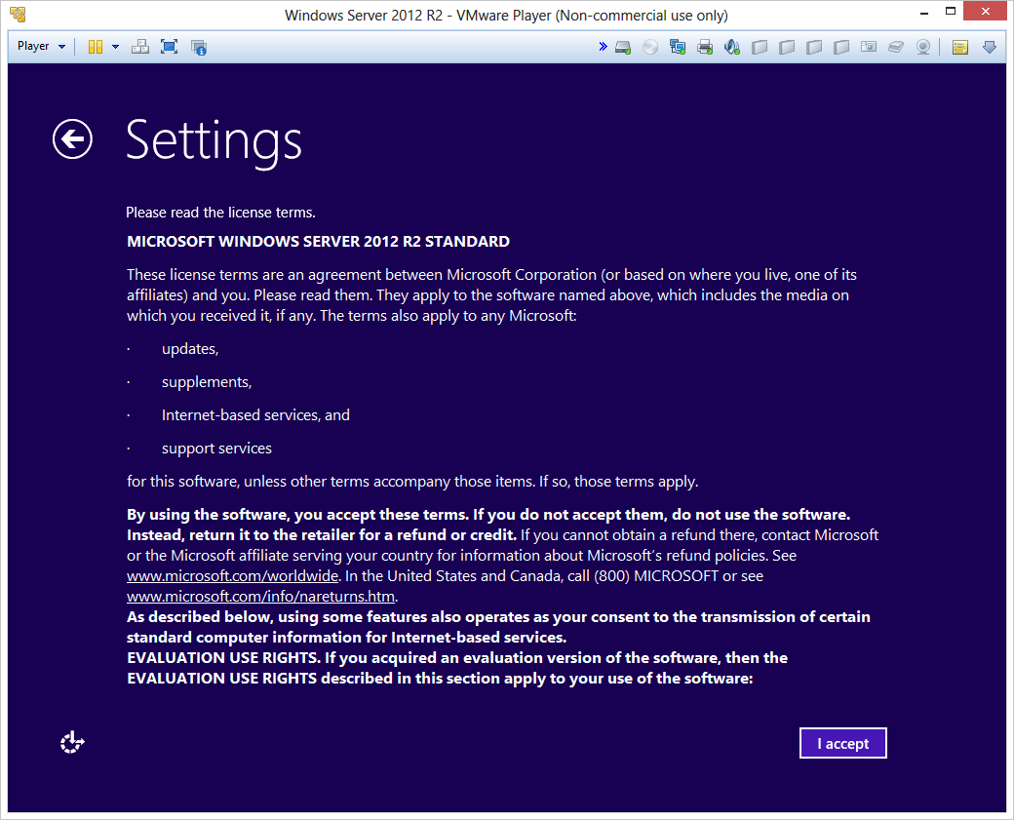
11. Click the I Accept button and continue.
12. Enter the password **Password1** as your new Administrator password.
13. Log into the server. Use the  button on the VMWare player toolbar to send a Ctrl + Alt + Del to the server.
14. Log on as the Administrator user with the password **Password1**.
15. If you see the Networks dialog that looks like this  
    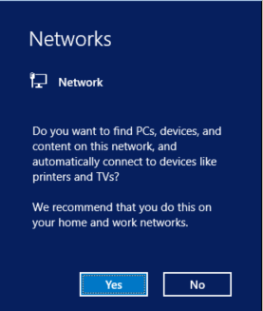  
    Click **Yes**
16. Wait a little while until the Server Managers starts. You should see the Server Manager Dashboard  
    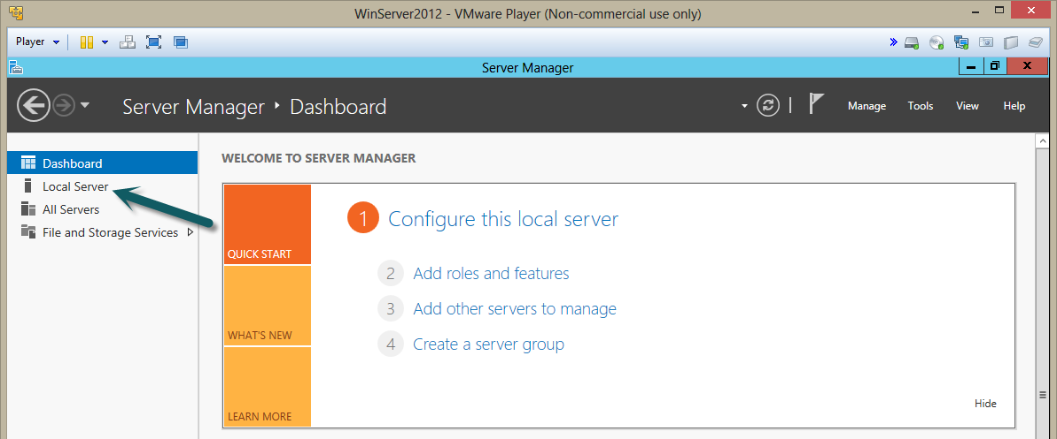
17. Click the **Local Server** Link to see the basic settings for the server. You should now see the server’s properties  
    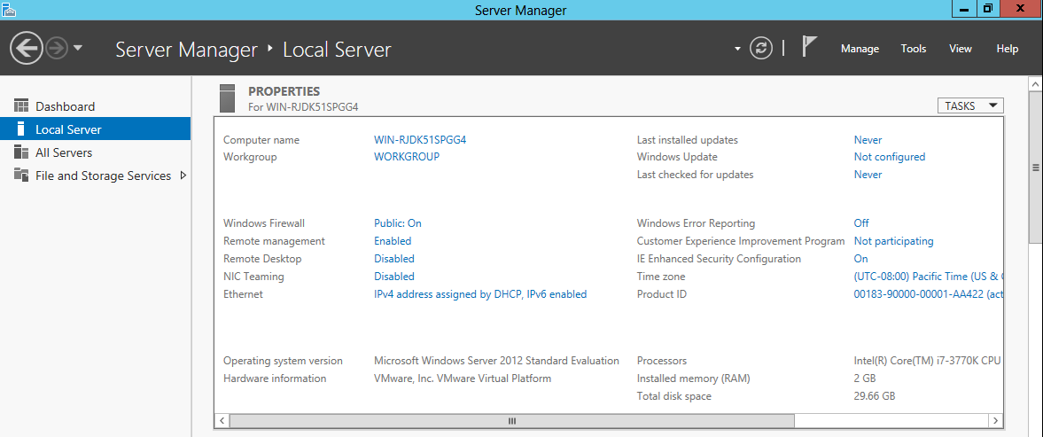
18. Click the **Windows Firewall** Link that says **Private On** (May say **Public On**).  
    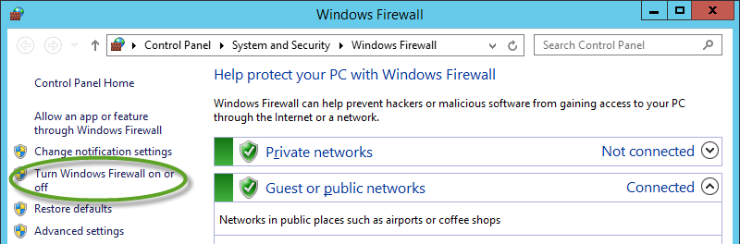  
    Click the **Turn Windows Firewall on or off** link
19. Click the **Turn Windows Firewall on or off** link.  
    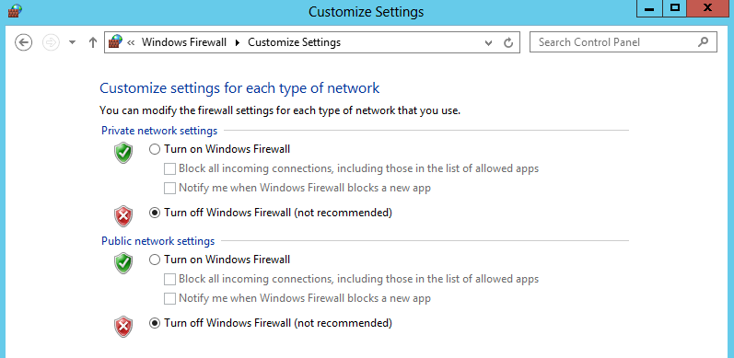
20. Turn the Firewall **off** for both Private and Public networks. Click **OK** to save your new firewall settings.
21. Close the Firewall configuration tool. (Server properties will not show this change yet).
22. Click the **On** Link next to **IE Enhanced Security Configuration**.  
    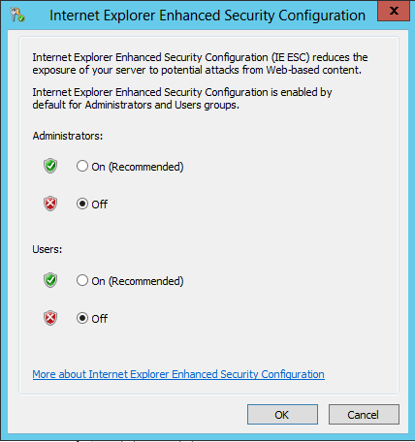
23. Turn both setting **off**. Click OK to dismiss the settings window.
24. Change/verify the time zone, set to Mountain Time if it is not already Mountian.  
    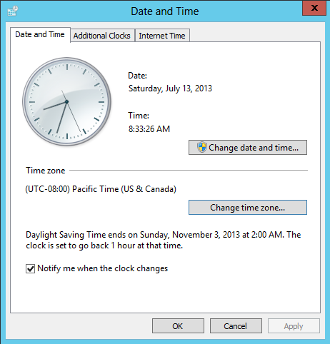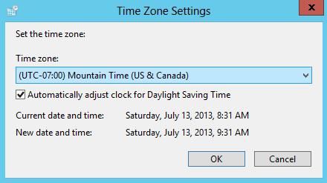
25. Finally change the computer name to WinServer.
    1. Click on the **Computer name** link.
    2. Click the **Change** Button on the Sever Properties screen. 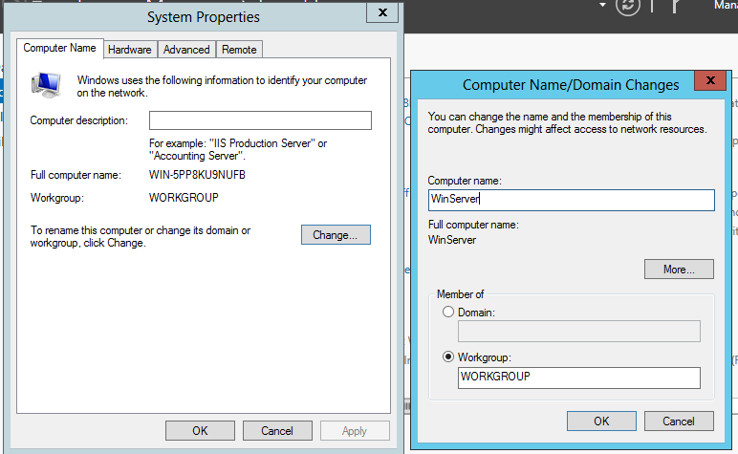
    3. Change the Computer name to WinServer then click OK.
    4. Click **OK** on the message box that informs you that the computer needs to be restarted to apply the changes.
    5. **Close** the System Properties window.
    6. Click **Restart Now** when requested.
26. When the machine reboots login as **Administrator** with the Password **Password1**.
27. After the Server Manager Starts Select **Local Server**, you should see the changes we made  
    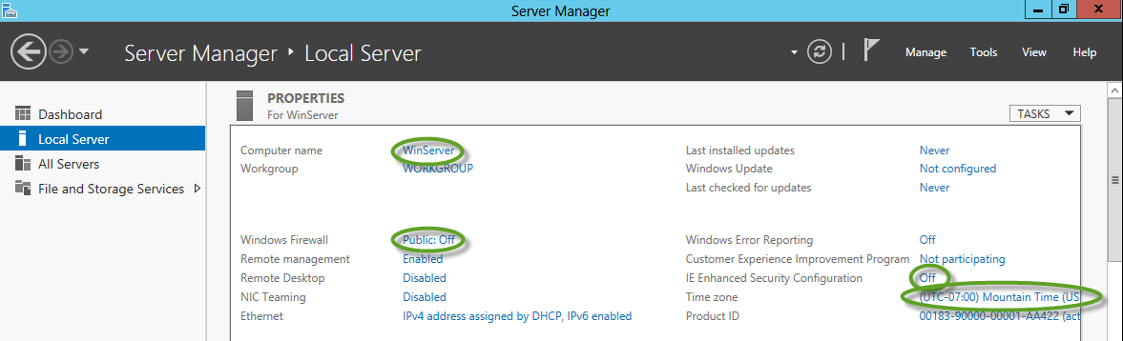
28. Installing Wireshark, you will need to install Wireshark on your server so we can perform protocol analysis.
    1. Open internet explorer on your Windows Server.
    2. Click the use recommended settings radio button and click OK.
    3. You can get Wireshark from the internet. If you need to move the Network adapter to NAT if you are still having problems with routing.
    4. Click **Run** When prompted.
    5. Click through the installer accepting all the defaults. While installing, Wireshark will launch the WinPcap installer accept all defaults.
29. Start your Debian1 VM
30. You should be ready to complete the lab exercise.

# Task 1—exploring DHCP

In this task you will use the Windows Server to explore DHCP. Linux uses DHCP as well but the nice graphical network configuration tool installed on your Debian VMs does not provide as much control as you will need for this Task.

## Steps

1. Launch PowerShell, by default PowerShell has a tile on the start menu or an icon  in the taskbar in Desktop mode (if you are unfamiliar with PowerShell, it is the replacement for the CMD.exe command prompt. It provides a powerful command and scripting environment).
2. In all versions of windows with TCP/IP installed the *ipconfig* program can be used to show IP configurations and manipulate the DHCP and DNS Clients. As of Windows 8, PowerShell offers a rich set of networking commands as well. This lab will focus on ipconfig.
3. From PowerShell enter the command  
   ipconfig
4. You will see output similar to (not the same as) this:  
   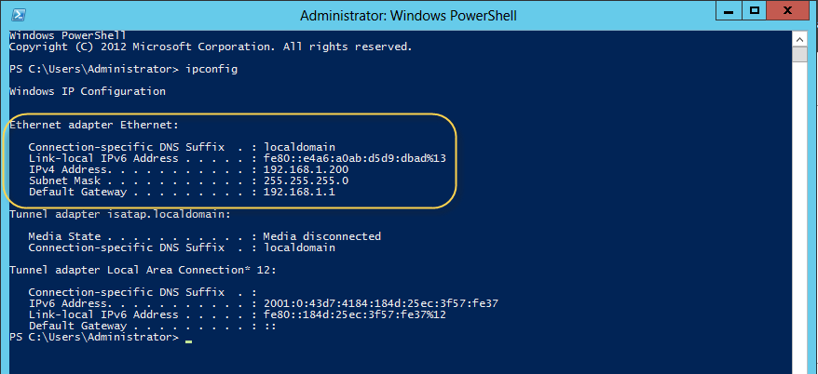
5. We are interested in the **Ethernet Adapter Ethernet0** section. The other sections are not for physical network adapters. By default ipconfig displays summary information for all adapters.
6. To see the full details about and adapter use the /all switch. Enter the command  
   ipconfig /all  
   notice the additional information. From the ipconfig results record answer the following questions about your Ethernet adapter.
   1. What is the physical address (MAC)? 00-0C-29-2C-EA-96
   2. Is DHCP enabled? Yes
   3. Is Autoconfiguration Enabled? Yes
   4. What is the IPv4 address? 192.168.1.117
   5. What is the Subnet Mask 255.255.255.0 /24
   6. When was the Lease Obtained? 5:35 PM
   7. When does the lease expire? 7:35 PM
   8. What is your Default Gateway? Nothing
   9. What DHCP server was used for the address? 192.168.118.254

# Task 2—renewing DHCP addresses

DHCP addresses are assigned on a lease basis. The client can only use the address until the lease expires at which time it must renew the address. If the address cannot be renewed the client must request a new address.

## Steps

1. Renewing addresses with a functioning DHCP server.
   1. From the ipconfig information above how long was the lease for this IP address (hint subtract the Lease obtained time from the Lease expires time? 2 hours
   2. Renew the lease by entering the command:  
      ipconfig /renew
   3. Enter the command  
      ipconfig /all  
      Record the following information
      1. IP address 192.168.1.117
      2. Lease Obtained 5:35 PM
      3. Lease Expires 7:39 PM
   4. Did the DHCP server give the client a new (different) address? No
   5. What happened to the Lease Expiration? It updated to 2 hours after the date I renewed it
   6. Did the Lease Obtained time change? The obtained time is the same as before though
2. Renewing a DHCP address when the DHCP server is offline.
   1. Now you will turn off the DHCP server. The DHCP server for VMNet11 is your pfsense firewall.
      1. Open internet explorer and navigate to **http://192.168.1.1** (your pfsense firewall).
      2. You will see a screen that indicates a security certificate problem. Click the link that says **Continue to the website**.
      3. Logon to pfsense with the user **admin** password **Password1**.
      4. Select **DHCP Server** from the **Services** menu.  
         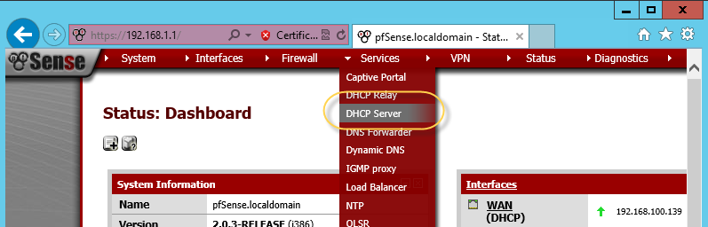
      5. **Uncheck** the **Enable DHCP server on LAN interface** checkbox then click **Save** (near the bottom of the screen).
   2. From PowerShell renew your IP address with the command  
      ipconfig /renew  
      You will need to wait a while. This is a good time to start your **Debian-1** VM
      1. What was the result of the command? An error occurred while renewing interface Ethernet0 : unable to contact your DHCP server. Request has timed out.
   3. View you IP settings with ipconfig /all and record the following information.
      1. IP address 192.168.1.117
      2. Lease Obtained 5:35 Pm
      3. Lease Expires 7:39 PM
      4. Did the DHCP server give the client a new (different) address No
      5. What happened to the Lease Expiration? It didn’t change
      6. Did the Lease Obtained time change? It didn’t change

# Task 3—no address no server

Now you will see what happens if you request a new IP address but there is no DHCP server to give you one. With both Linux and Windows.

## Tasks

1. Windows
   1. Getting rid of the current IP address.
   2. Use the IP ipconfig command to release the IP address your Widows computer is using. Enter the command:  
      ipconfig /release
   3. Now view your IP configuration with ipconfig and answer the following questions
      1. Does your computer have an IPv4 address? Yes If so what is it? 169.254.6.168 from Autoconfig (if your computer does not have and IPv4 address wait a little bit then enter the ipconfig command again)
      2. Was it assigned by a DHCP server (use ipconfig /all)? No, it was assigned atomatically
   4. Can you ping google with this IP address? Enter the command   
      ping 8.8.8.8  
      Was it successful? Nope
   5. The special IPv4 address block of 169.254.0.0/16 is set aside for link local addresses. These addresses are used by an interface to create a self-assigned address when no DHCP server is available. The addresses are said to be “link-local” because they are not routable, thus you can only communicate with other devices on the same layer 2 network with these addresses. They are defined in RFC 3927. Microsoft's term for this is Automatic Private Internet Protocol Addressing (APIPA).
      1. Now explain why your ping to google was not successful It technically doesn’t have an IP address, so the request can’t go anywhere. Even if it could get to the router, the packet wouldn’t be passed on.
2. Linux
   1. From Debian-1
   2. Return your VM to use DHCP to get an IP address.
      1. Open the Wicd Network manager (start🡪internet🡪Wicd network manager)
      2. Open the properties for the network adapter.
      3. **Uncheck** the **Use Static IPs** checkbox.
      4. **Uncheck** the **Use Static DNS** checkbox.
      5. Click OK to save your settings.
   3. For the changes to take effect you need to restart the network. Click the **Connect Button** (If there is no connect button click the disconnect button then the connect button).
   4. The progress bar will bounce around for some time. After it stops (it will take a while) open a terminal and use the command **ifconfig** to view your network settings.
      1. Does you Debian machine have and IPv4 address? Nope If so what is it? None
      2. How does Debian differ from Windows when an address cannot be obtained from a DHCP server? It doesn’t have automatic IP addresses like windows does

# Task 4—examining the DHCP protocol

In this task you will use the Windows Server to capture and analyze DHCP protocol traffic.

Steps

1. Turn DCHP server back on
   1. From your Debian 1 VM connect to the pfsense firewall. (you will need to set Debian 1 back at a static IP address such as 192.168.1.11 to do this)
   2. Turn the DCHP Server back on
      1. From Debian 1 use your web browser to connect to your pfsense firewall (username **admin** password **Password1**).
      2. From the **Services** menu select **DHCP Sever**.
      3. Check the **Enable DHCP server on LAN** interface check box
      4. Click the **Save** button.
2. Capturing DHCP traffic.
   1. From your WinServer, clear your IP address from your server. Enter the command  
      ipconfig /release
   2. Start Wireshark on your Windows Server (from the start screen just start typing Wireshark then click on the link when it is found.
   3. Select the Ethernet0 adapter and Start capturing data
   4. Request a new address, enter the command   
      ipconfig /renew
   5. After the command completes stop the Wireshark capture.
3. Examine the DHCP protocol
   1. Your Wireshark capture will likely have a lot more data than you have seen in the past. To view just DHCP frames you can enter a filter. If you recall from class DHCP uses bootp (bootstrap protocol). Enter **bootp** in the Filter box then press **enter**.  
      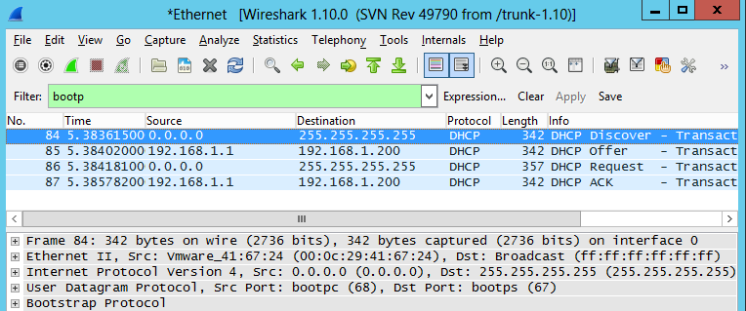
   2. The frame list should be filtered to bootp messages.
   3. Examine the DCHP Discover
      1. Does DHCP use TPC or UDP for its transport protocol? UDP
      2. What is the destination IP address for the Discover? 255.255.255.255
      3. What is the source IP address? 0.0.0.0
      4. What is the source MAC address? 00:0C:29:2C:EA:96
      5. What is the Destination MAC address? Ff:ff:ff:ff:ff:ff
   4. Examine the DHCP offer (the details will be in the Bootstrap Protocol node information, look at the options.
      1. What Information is being offered to the client (List all) Client MAC address, Client Identifier, Requested IP address
      2. What IP address is being offered to the client? 192.168.1.117
4. Verifying the configuration. From PowerShell enter the command  
   ipconfig /all   
   examine the output.
   1. Compare the information reported with the information from the DHCP offer. Does the data match? Yes

# Task 5—Using DHCP Reservations

DHCP is very convenient way to configure IP addresses. However sometimes you want a computer to have a specific IP address. Some DHCP servers provide a feature called a reservation. A reservation is an IP address that can only be given to a specific network adapter. The adapter is identified by its MAC address. For this example you will create a reservation for the windows server so that it will always get the IP address of 192.168.1.10.

## Steps

1. Record the MAC address of your Windows server. You can get your hardware address using ipconfig, or more easily with the PowerShell command:  
   Get-NetAdapter
2. Record the MAC address for the Ethernet adapter on your Windows Server here? 00-0C-29-2C-EA-96
3. Using a web browser connect to the pfsense firewall.
4. From the Services Menu select DHCP server.
5. Scroll to the bottom of the screen. You should see the Static Mapping table  
   
6. Click the button with the + on it to add a new reservation.
   1. Enter the mac address of your Windows server in the Mac address box. (Note windows displays MAC addresses with bytes separated with -s like xx-xx-xx-xx-xx-xx whereas pfsense uses : to separate bytes of the address like xx:xx:xx:xx:xx:xx )
   2. Enter **192.168.1.10** for the IP address
   3. Enter **winserver** for the host name
   4. Enter **Windows 2012 R2 Server** for the description.
   5. Click **Save** to create the reservation
7. Click the **Apply Changes** button at the top of the screen to update the DHCP server configuration
8. Test the reservation.
   1. From PowerShell on our windows server release the IP address  
      ipconfig /release
   2. Now request a new address  
      ipconfig /renew
   3. Verify the address, view the IP address, did you get the reserved address? Yes I did If not troubleshoot.
9. Create a reservation for **Debian-1** to always get the IP address of 192.168.1.11. You can get your Debian's MAC address using the ifconfig command, look at the **HWaddr** for **eth0**
   1. Make sure you save and apply the changes.
10. Now your Windows Server and Debian-1 will always get the same IP address from the DHCP server on the pfsense firewall.
11. Take screen shot of your firewall's reservations and paste it here. (hint use the snipping tool)  
    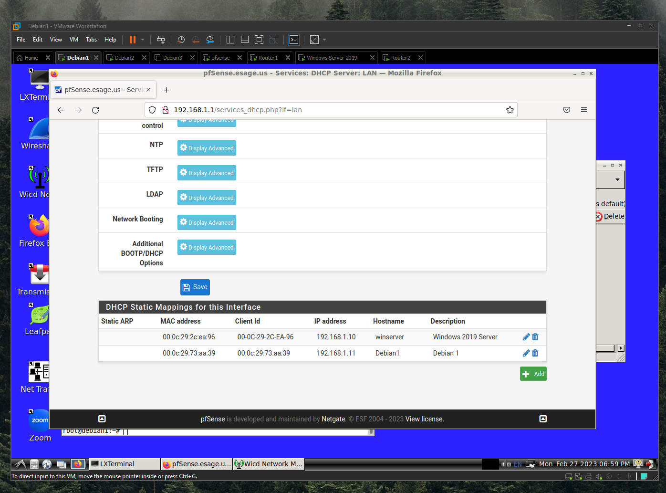
12. Configure Debian-1 to get its IP address and DNS from DHCP by editing the network connection. Remember to disconnect and reconnect the network for the changes to be applied.
13. Use the ifconfig command to view your ip configuration.
    1. Did Debian-1 get the proper IP address? Yes, yes it did!

# Deliverable

Upload this document with completed answers to canvas.